NETWORK SECURITY, MAINTENANCE AND TROUBLESHOOTING PROCESS

BUILD A SOHO NETWORK
TASK1: Draw a network diagram for a small office/home office (SOHO) setup that includes: one broadband internet connection, one Wi-Fi router, two laptops, one smart TV, and one printer. Clearly label each device and connection type (wired or wireless).
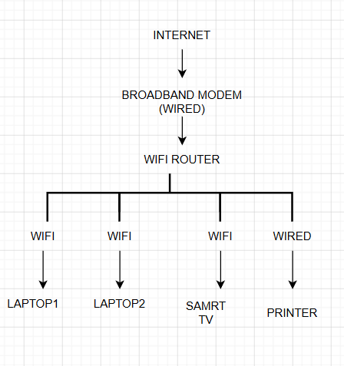
- Internet → Router → Wired
- Router → Laptop 1 → Wireless (Wi-Fi)
- Router → Laptop 2 → Wireless (Wi-Fi)
- Router → Smart TV → Wireless (Wi-Fi)
- Router → Printer → Wired (Ethernet)

TASK2: List all the hardware components (with brand/model suggestions) you would need to physically build the SOHO network diagrammed above, including cables and any switches or extenders if needed.<br><br><em><strong>Hint:</strong> Check current listings on Flipkart or Amazon for typical device models used in Indian homes/offices.</em>
Hardware | Suggested Brand/Model | Purpose
Broadband Modem | Airtel/Jio/BSNL Modem | Internet connection
Wi-Fi Router | TP-Link Archer C6 | Shares internet
Laptop 1 | HP 15s | Office work
Laptop 2 | Dell Inspiron 15 | Office work
Smart TV | Samsung Smart TV | Streaming/Meetings
Printer | HP DeskJet 2331 | Printing documents
Ethernet Cable (Cat6) | D-Link Cat6 Cable | Wired connection
Network Switch (Optional) | TP-Link TL-SG105 | Extra LAN ports
Wi-Fi Extender (Optional) | TP-Link RE205 | Increase Wi-Fi range

TASK3: Write step-by-step instructions to configure the Wi-Fi router for your SOHO network, including setting up a unique SSID, enabling WPA2 security, and changing the default admin password.
- Connected the router to the broadband modem.
- Connected the laptop to the router.
- Opened a web browser.
- Entered the router IP address: 192.168.0.1 OR (or 192.168.1.1)
- Logged in using the default username and password.
- Changed the Wi-Fi name (SSID) to: OfficeWiFi
- Selected WPA2-PSK as the security type.
- Created a strong Wi-Fi password.
- Changed the router's default admin password.
- Clicked Save and restarted the router.

TASK4: Configure IP addresses for all devices in your SOHO network: assign static IPs to the printer and smart TV, and use DHCP for the laptops. Show a table listing each device, its MAC address (make one up), and the assigned IP address.
Device | MAC Address (Example) | IP Address | Configuration
Router | 00:11:22:33:44:55 | 192.168.10.1 | Default Gateway
Laptop 1 | A1:B2:C3:D4:E5:F1 | 192.168.10.100 | DHCP
Laptop 2 | A1:B2:C3:D4:E5:F2 | 192.168.10.101 | DHCP
Smart TV | 5C:6D:7E:8F:90:11 | 192.168.10.20 | Static
Printer | 2A:3B:4C:5D:6E:7F | 192.168.10.10 | Static

TASK5: Explain how you would troubleshoot if one of the laptops cannot connect to the internet in your SOHO network. List at least 3 possible causes and what steps you would take to diagnose and fix each issue.
PROBLEM: LAPTOP CANNOT CONNECTING TO THE INTERNET
Cause 1: Wi-Fi is turned off
Solution:
- Check if Wi-Fi is enabled.
- Turn Wi-Fi on.
- Reconnect to the Wi-Fi network.
Cause 2: Incorrect Wi-Fi Password
Solution:
- Forget the Wi-Fi network.
- Enter the correct password.
- Connect again.
Cause 3: No IP Address
Solution:
- Open Command Prompt.
- Type: ipconfig /release
- Then Type: ipconfig /renew
- Check if the laptop receives a valid IP address.
Cause 4: Router Problem
Solution:
- Restart the router.
- Wait for 2–3 minutes.
- Try connecting again.

